**Project 6 Coin Detection – 2nd Semester**

Name: Forrest Meng Period: 2 Date: 2/5/2020

Did you create the edge matrix? Yes

Did you create the gradient direction matrix? Yes

Did you identify circles? Yes

Below do the following for each of the 3 images provided (so 9 images and 3 content of results.txt):

1. Paste here 3 clear picture of the initial picture, the picture with the edges, the picture with the original image and the circles you detected drawn in red.
2. Paste the content of your results.txt file

Image 1:

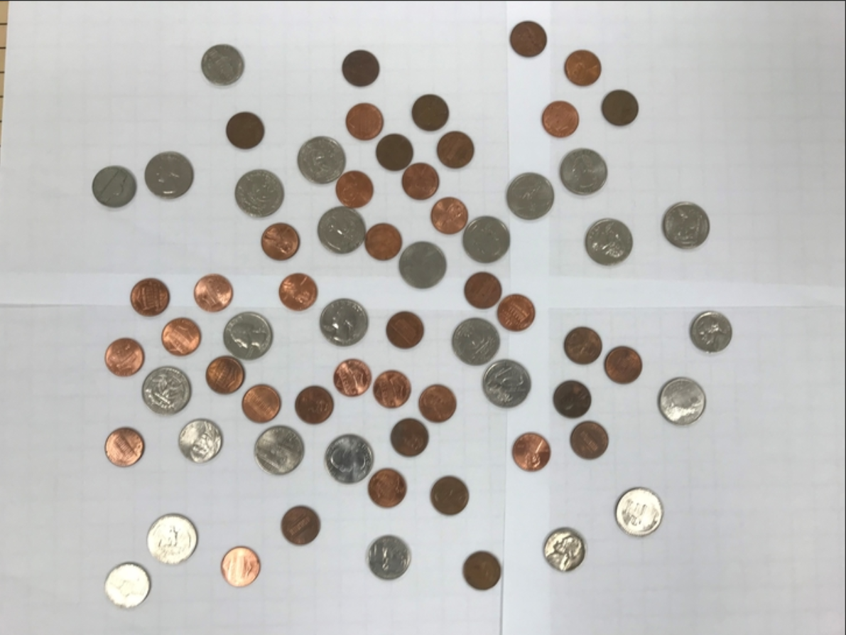

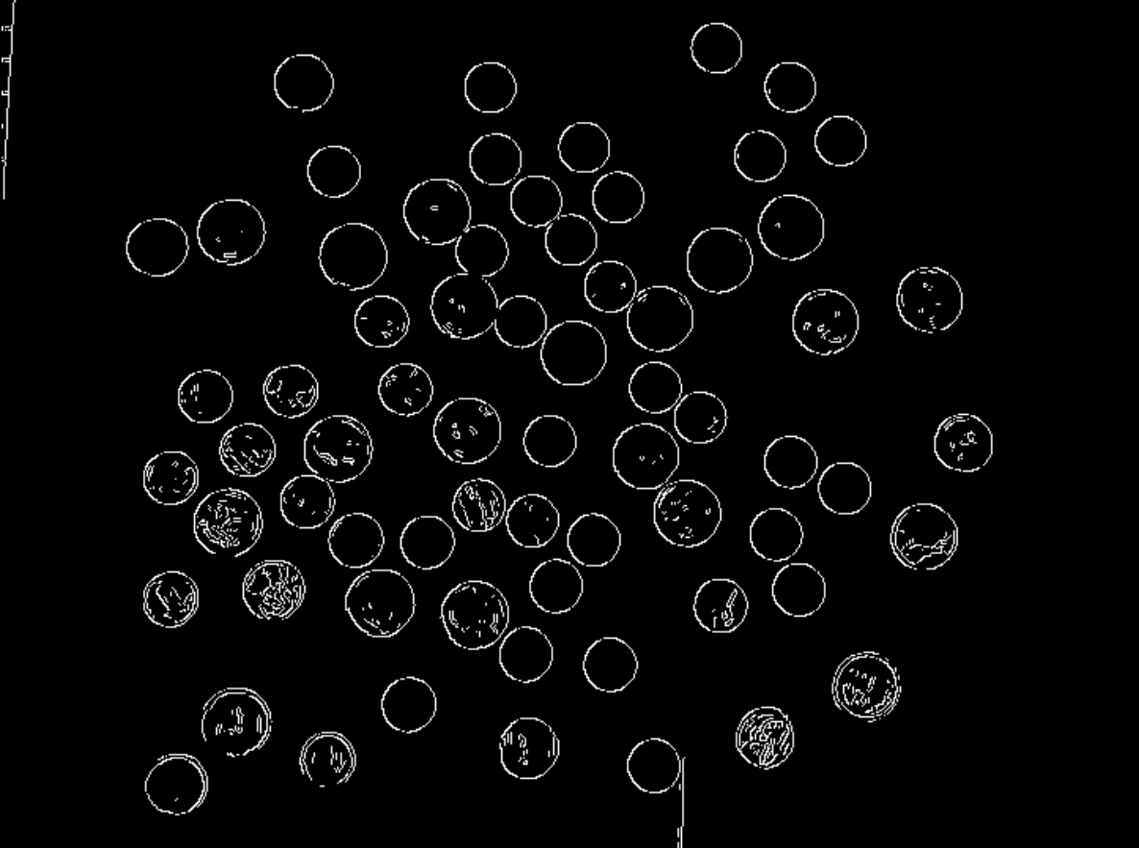

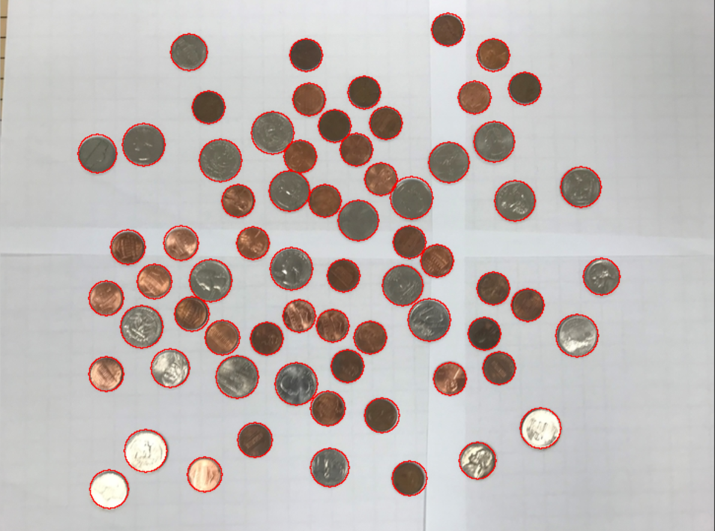

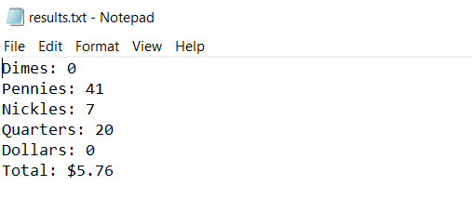

Image 2:

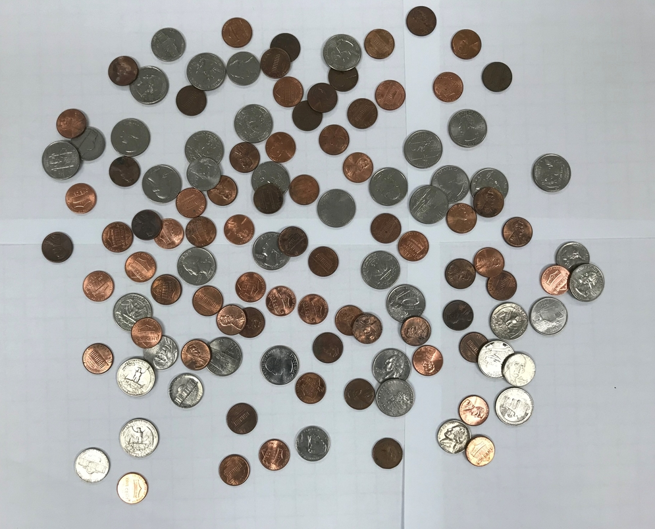

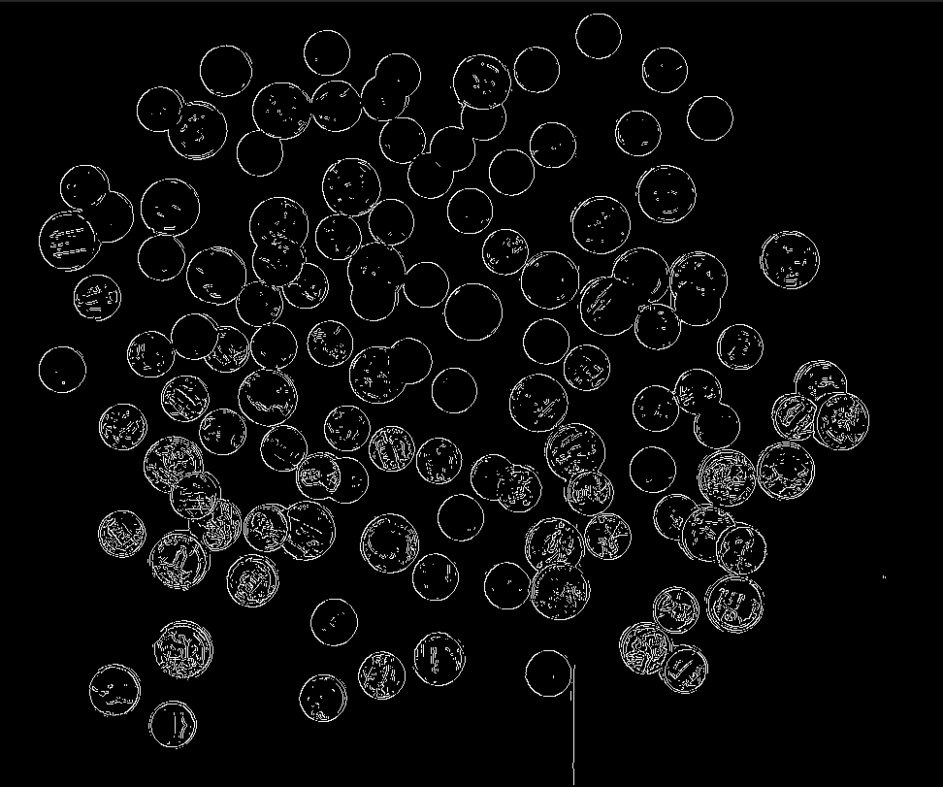

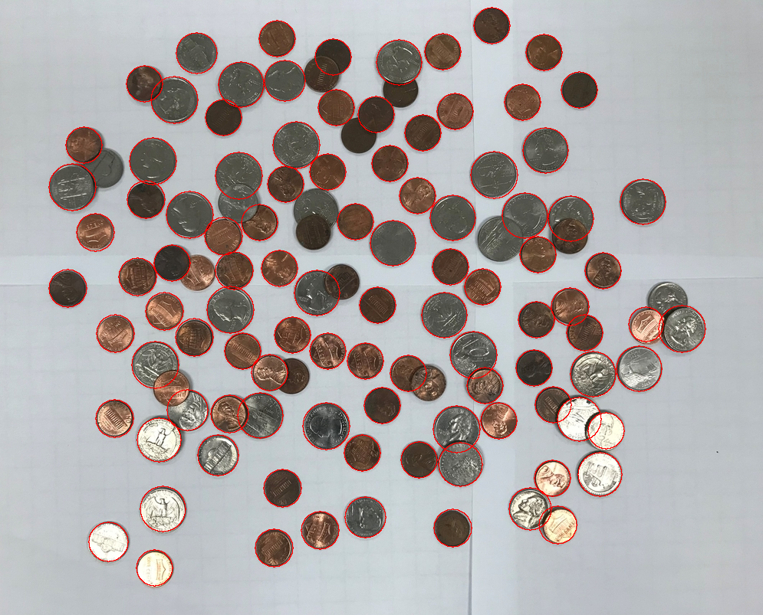

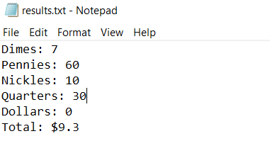

Image 3:

